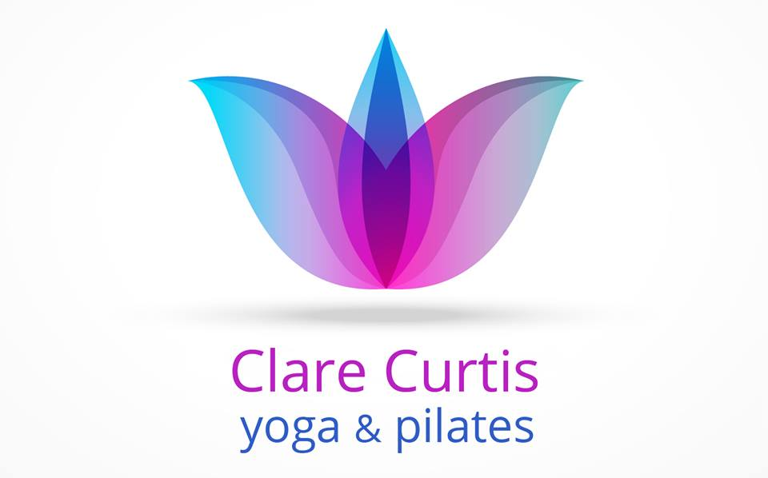

**PILATES & YOGA HEALTH SCREENING QUESTIONNAIRE-CONFIDENTIAL**

To be completed by yoga and/or Pilates class participants for face to face and remote teaching. All information given will be treated in the strictest confidence and stored in accordance with General Data Protection legislation.

Name:__________________________________ Tel:______________________________ Age:_______

Occupation__________________Emergency contact name & no:_________________________

E.mail:_________________________________________________________________________________

May I use this e.mail to add to my mailing list for class news? YES / NO

Yoga/Pilates experience:_______________________________________________________________

What are your interests/hobbies?_________________________________________________________

_______________________________________________________________________________________

What are your goals in attending the sessions?___________________________________________

______________________________________________________________________________________

**Please read the following carefully and answer each one as honestly as you can.**

The following information is required to ensure your health. Whilst yoga and/or Pilates may be practised safely by most people, there are certain conditions that require special attention. If you are unsure, please consult your GP before commencing class.

1) Are you on any medication that may affect you during the session? YES NO

If you answered YES please give details:

______________________________________________________________________________________

______________________________________________________________________________________

______________________________________________________________________________________

______________________________________________________________________________________

2) Have you any medical conditions or disabilities? YES NO

If you answered YES please give details:

______________________________________________________________________________________

______________________________________________________________________________________

______________________________________________________________________________________

______________________________________________________________________________________

3) Do you have any injuries, joint problems or joint replacements? YES NO

If you answered YES please give details:

______________________________________________________________________________________

______________________________________________________________________________________

______________________________________________________________________________________

______________________________________________________________________________________

4) Have you had any recent operations (in the last two years)? If yes please give details:

____________________________________________________________________________

______________________________________________________________________________________

______________________________________________________________________________________

5) Are you / could you be pregnant or have been in the last 6 months? YES NO

6) Are there any other conditions that your teacher should be aware of that might be adversely

affected by yoga/Pilates practice ? YES NO

If you answered YES please give details:

______________________________________________________________________________________

______________________________________________________________________________________

______________________________________________________________________________________

Disclaimer

Please read carefully; your submission of this form will be taken to indicate your understanding and acceptance of the following:

Please take care when filling in this questionnaire and check the contents are accurate before you submit it. By submitting the questionnaire, you are confirming that the contents are true and accurate to the best of your knowledge. Please notify your teacher of any changes to your responses in this healthcare questionnaire before participating in classes subsequent to those changes.

Please obtain professional or specialist advice from your doctor before participating in the class if you are in any doubt.

Where possible, the teacher will offer suitable modifications or adjustments and practices to suit different levels of experience and ability. Please note, where you are taking part in a pre-recorded class, you will not be able to request specific adjustments or modifications so contact the teacher to pre-request or with any questions.

Where you are taking part in live-streamed classes, please note that the instructor may not be able to see you at all times. Where you have declared a health condition, please contact the teacher before the class.

In all classes whether face to face, live streamed remote or pre-recorded remote, always follow your teacher’s safety instructions and listen to your body. Where a movement or class is beyond your experience or ability, feels too difficult for you, or you experience any discomfort, please do not continue the movement or class.

Name (please print):

Signature

If you are using a printed out paper copy:

Otherwise indicate with a tick or X ………………………………………………………………………………… I confirm my understanding and acceptance of this health questionnaire and its disclaimer:

Date:

GDPR Statement

In order to comply with the General Data Protection Regulations, it is necessary for me to check whether or not you are happy for me to retain your contact details, and to send you information that I think may be useful to you regarding the classes, and relevant updates. I only hold information when it is necessary to do so in order for me to carry out my work, and when you have given me permission to do so. To ensure that I only communicate with you in the manner of your preferred choice, please will you indicate below, your agreement, or otherwise, to the following means of communication:

E.MAIL: YES / NO TELEPHONE: YES / NO